The Roaring 20’s Presentation

Unit 5: The Roaring Twenties/Jazz Age
PRESENTATION REQUIREMENTS

PRESENTATION DATES:
My Group Topic: ___________________________________
A DAY – Friday, Dec 4th
B DAY- Monday, Dec 7th My Presentation Date: _____________________________
A DAY – Tuesday, Dec 8th
B DAY- Wednesday, Dec 9th Group Members: ___________________________________
_______________________________________________________

GROUP PRESENATION REQUIREMENTS:
Your presentation must be at least 8 minutes and no more than 12 minutes long.
Your presentation consists of three different parts, which include:

- Teaching (5 min) – presentation of information, you can use PowerPoint, give the information verbally with posters or pictures to pass around, or use another method. If you use PowerPoint, do not think you may simply read the information to us off of your slides. You need to make this presentation interesting as well as informational. You need to focus your presentation on the following:
  - Basic background of your topic (include pictures)
  - What impact your topic has on American history?

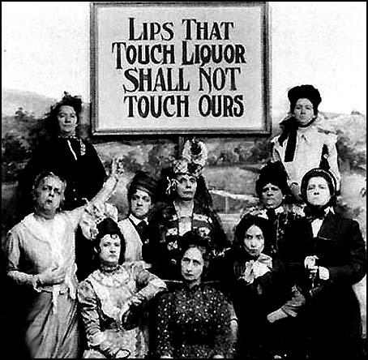
- Creative Presentation (2 min) – this can include a skit, a video, music, or some other idea you approve with me. Make sure that it is relevant to your topic, as well as fun and entertaining for the class.

- Reinforcement of Information (3 min) – you may use a class discussion, a game, a quiz, etc.

Other Requirements:
- During presentations, the audience will be required to take notes. At the end of your presentation, include a slide that shares the five (5) most important aspects that students need to take away from your presentation. Remember, YOU are responsible for what the class learns.
- You must provide a Works Cited Page that lists all the resources you used to gather information.
- Each person from your group needs to be equally involved in both the planning and presenting.

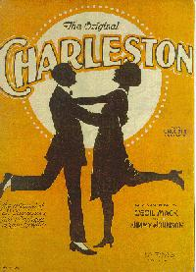
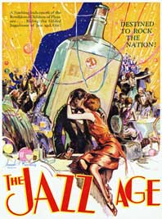
During this class period and the next, you will be able to work on your project, however, if you do not finish in class, you will need to meet outside of class to complete all of the requirements. As you prepare for your project, make sure you practice giving your presentation. You will be
graded on how well you present the information as well as what information you present.

DAY 1 TASK
- Create a GOOGLE SLIDES presentation (create a title slide, put all group names on it, SHARE with everyone in your group AND Mr. Morris. jdmorris@alpinedistrict.org
- Exchange contact information with your group (cell phone is preferred, but also email if necessary)
- Come get the Key Terms from teacher and prove you’ve shared your presentation.
- Divide up research responsibilities and complete research on the different key concepts/ideas of your topic.
- Begin making slides, gathering images, and saving your links to websites.
- Brainstorm ideas for Creative Presentation and Reinforcement Activity.
- HOMEWORK: ALL research should be completed before you come back to class.

Day 2 TASK
- Work together to make/finish slides.
- Finalize plans for Creative Presentation & Reinforcement Activity.
- Discuss/plan/rehearse student roles and responsibilities during the presentation.
- Make sure to review over the checklist below to make sure you have completed all aspects of the assignment.
- Practice, Practice, Practice.

Project Checklist:

- 5 minute - Content/Background Information (in slides)
- 2 minutes – Creativity (song, skit, video, etc)
- 3 minutes – Reinforcement (game, discussion questions, activity)
- “5 Most Important Facts” slide
- Works Cited slide

Can You Say “YES” To The Following?
- Do we have a works cited page?
- Do you know the basic background and key terms of your topic?
- Have you included information on the IMPACT your topic has had on American History?
- Do we have a slide with the “5 Most Important Facts?”
- Does it include pictures? (It should!!)
- Is it in bullet point form with limited writing? (It should!)
- Will we be between 8-12 minutes?
- Do we know who is speaking when/what?
- Does everyone have a role/involved in the presentation?
- Have we adequately prepared?
- Did we do our best work?
- Will we be engaging?
- Do we want to dress up? In character? Formal? (Extra Credit)

Topics:
1. Prohibition and Organized Crime
2. Scopes Monkey Trial/Modernity vs fundamentalism
3. Red Scare/Palmer Raids/Sacco and Venzetti
4. Jazz and Entertainment
5. Henry Ford and American Consumerism (Credit)
6. Flappers/Women’s Roles/Rights
7. Radio and Advertising
8. Racial Tensions/Urban Migration/Harlem Renaissance
9. New Inventions (excluding radio and car)

